FS00 – Create General Ledger Account

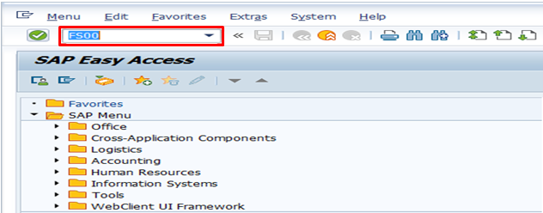

- Input FS00 in Transaction Box and press Enter key

General Ledger Type/Description Tab.

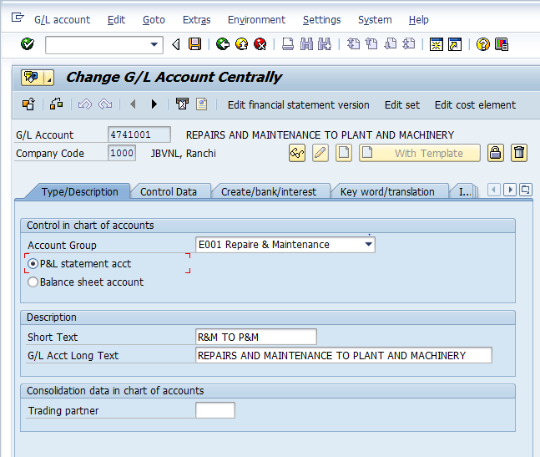

- Account Group: Select the relevant Account Group from drop-down list
Select relevant Account type
- P&L statement acct or
- Balance Sheet Account
- Short Text: Input short text for the G/L account
- G/L Acct Long Text: Input long text for the G/L account

General Ledger Control Data Tab.

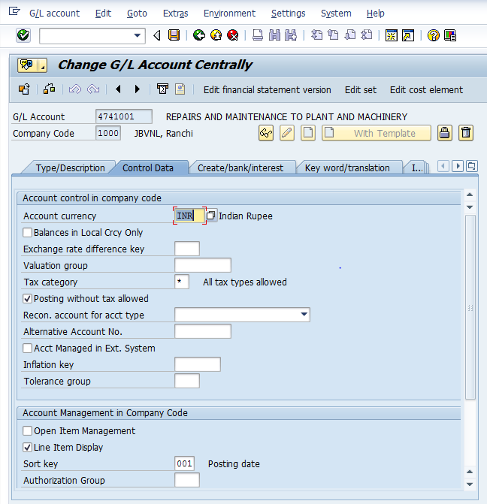

- Account Currency: Input G/L account currency
- Only balances in local crcy: Select this option for all current liabilities account
- Tax Category: Select the relevant tax category with the help of F4 key.
(Note: Selecting “*” will allow all types of taxes)
- Posting without tax allowed: Selecting this option will allow to post the transaction without tax even though tax is mandatory.
- Recon. account for acct type: Select the relevant reconciliation account type from drop-down
Assets: Select this option for Accumulated Deprectiation and Asset G/L’s
Customers: Select this option for Customer Advance and Customer G/L’s
Vendors: Select this option for VendorAdvance and Vendor G/L’s
- Open Item Management: Select this option for all the Banlance sheet payable accounts
- Line Item Display: Select this option to see the line item wise report
- Sort Key: Select required sort key with the help of F4 key

General Ledger Create/bank/interest Tab.

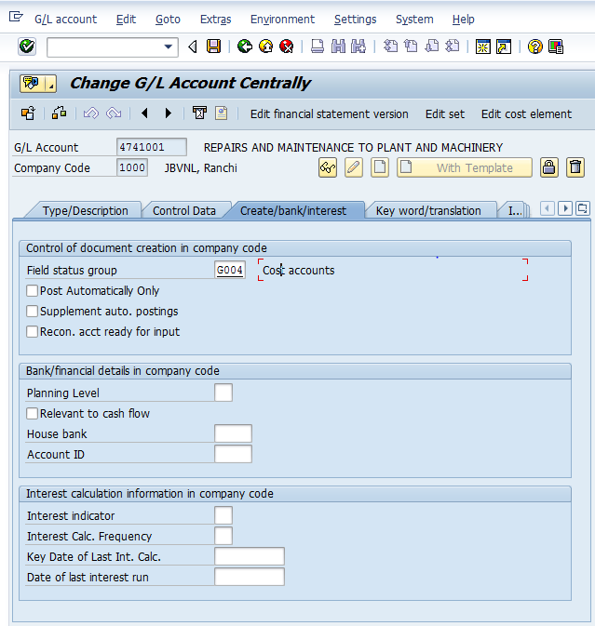

- Field status group: Select the relevant field status group with the help of F4 key
- Post automatically only: Select this option for the accounts for which we do not post the transaction manually.
- Relevatnt to cash flow: Select this option to update the cashflow related G/L’s
- Commitment Item: Select the relevant commitment item with the help of F4 key
- House Bank: Select the relevant house bank with the help of F4 key
- Account ID: Select the relevant account id with the help of F4 key
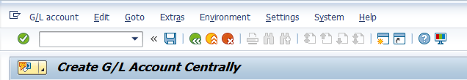

- Click on Save icon or press Ctrl+S keys to save the data.

- Data saved massege will appear at the bottom of the screen.

Manual End

